Installing and Running PyOpenGL (Windows)

Introduction

The following is intended to supplement the chapter on Stereo Camera Setup, and assist the user in installing Python, PyOpenGL, and also running the demonstration programs.

The demonstration programs are ideally designed for a widescreen display of width 518.4mm and height 324mm.
The initial window will open up at a size of 800/600 pixels – open to full screen size to see intended perceived depth.
All values are defined as millimetres throughout.

Two camera models are implemented – Toed-in and Parallel. When running, the user is presented with an array of 15 cubes, with the centre cube under rotation. When viewed in stereo on the intended display at full screen size, the user should view at a distance of approximately 1 metre, at which point the rotating centre cube should appear at roughly 10cm negative parallax (10cm out of the screen) with the remaining cubes appearing directly on the screen pane.

Installing Python

Install the latest version on Python, which can be obtained from www.python.org/download

The version at the time of writing is 2.6.2

Install using the installer package for current version of python

When Installed it is more than likely that the Path under System Variables will need to be edited – As Below….

Select Control Panel
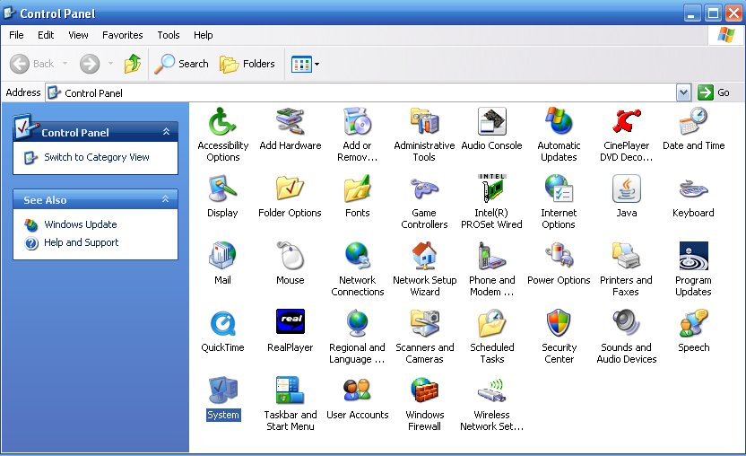

Select System – Advanced tab
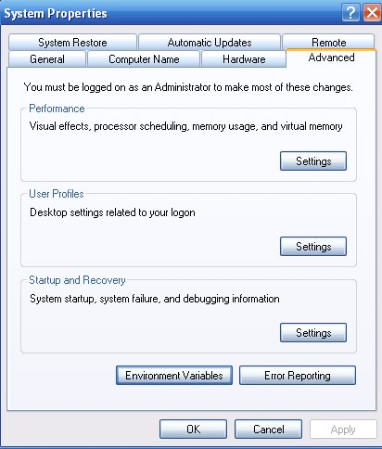

Select Environment Variables, and under System Variables choose Path, and select edit –
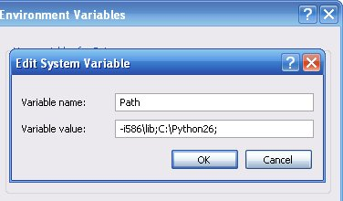

C:\Python26; will not yet exist – this will need to be added to the Path variable in order that Python can be accessed from the command line.

(!!!Folder containing Python installation may differ from Python26, depending on the version)

(Assuming Python was installed onto the root of C:\ drive)
Add ;C:\Python26; remembering that a semi colon ; separates each entry.

Once these settings are applied, python functions can be called from the command line.

To test, open the command prompt……. Start, Run, and type ‘cmd’

Once in the command prompt, type ‘python’ as below and the python interpreter will run….

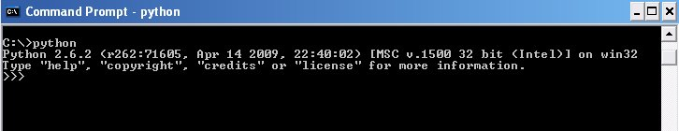

Python is successfully installed!

Installing PyOpenGL

Next, PyOpenGL, (The OpenGL binding for Python) will need to be installed.

Information on PyOpenGl can be found at http://pyopengl.sourceforge.net/

A simple method of installing PyOpenGL is using easy install (ez_setup.py) – this can be obtained from - http://pyopengl.sourceforge.net/documentation/installation.html

Download ez_setup.py and save to an easily accessible drive – i.e C:\
Open a new Command Prompt, and in the root of drive C:\ (or where ez_setup.py exists)
type:
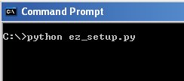

If a live internet connection exists, ez_setup.py will download and install easy_install into the folder for your Python installation.

The Path variable will now need to be changed again to access easy_install from the command line,
As before – open Environment Variables, and edit Path in System Variables.
Easy_install has been installed into the Scripts folder of the Python installation. This is the folder to where the Path must be directed in order to access easy_install.

In addition to the previous entry, add C:\Python26\Scripts as below

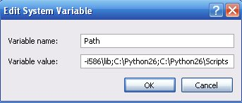

After applying these settings, open another new Command Prompt and type:

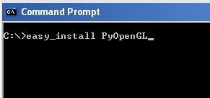

Again, an active internet connection is required in order for the installation to function.
Once complete, PyOpenGL should be successfully installed on the system.

Running the demos

If the above steps have completed successfully, the demos will now run.

Download, and save both the Parallel, and Toedin demos onto a local accessible drive.

Both demos have 3 options for display – SHUTTER; ANAGLYPH and NONE

The below section of code is common to both Toed-in and Parallel demo’s, it is responsible for determining whether the user has specified viewing mode to be SHUTTER, ANAGLYPH, or NONE. And rendering the Buffers accordingly.
If NONE is selected, only one Buffer (Left) will be drawn, suitable for Mono viewing.

def display( ):
"""Glut display function."""
if stereoMode != "SHUTTER":
glClear(GL_COLOR_BUFFER_BIT | GL_DEPTH_BUFFER_BIT)

if stereoMode == "SHUTTER":
setLightColor( "white" )
glDrawBuffer( GL_BACK_LEFT )
glClear( GL_COLOR_BUFFER_BIT | GL_DEPTH_BUFFER_BIT )
render( GL_BACK_LEFT )
glDrawBuffer( GL_BACK_RIGHT )
glClear( GL_COLOR_BUFFER_BIT | GL_DEPTH_BUFFER_BIT )
render( GL_BACK_RIGHT )
elif stereoMode == "ANAGLYPH":
glDrawBuffer( GL_BACK_LEFT )
glClear( GL_COLOR_BUFFER_BIT | GL_DEPTH_BUFFER_BIT )
setLightColor( "red" )
render( GL_BACK_LEFT )
glClear( GL_DEPTH_BUFFER_BIT )
glColorMask( False, True, False, False )
setLightColor( "green" )
render( GL_BACK_RIGHT )
glColorMask( True, True, True, True )
else:
glDrawBuffer(GL_BACK_LEFT)
glClear(GL_COLOR_BUFFER_BIT | GL_DEPTH_BUFFER_BIT)
setLightColor( "white" )
render(GL_BACK_LEFT)
glutSwapBuffers( )

The final section of code below is also common to both demos.

if len( argv ) != 2:
print "Usage:"
print "python stereDemo.py SHUTTER | ANAGLYPH | NONE \n"
else:
glutInit( sys.argv )
stereoMode = sys.argv[1].upper( )
if stereoMode == "SHUTTER":
glutInitDisplayMode( GLUT_STEREO | GLUT_DOUBLE | GLUT_RGB | GLUT_DEPTH )
else:
glutInitDisplayMode( GLUT_DOUBLE | GLUT_RGB | GLUT_DEPTH )
glutInitWindowSize( 518, 324 )
glutInitWindowPosition( 100, 100 )
glutCreateWindow( sys.argv[0] )
init( )
glutDisplayFunc( display )

glutIdleFunc( animationStep )
glutMainLoop( )

Initially a check is made to ensure the user inputs at least two arguments to initiate the program, the second of which must be SHUTTER, ANAGLYPH, or NONE.

Next, if the user has input SHUTTER, the program will attempt to call:

glutInitDisplayMode( GLUT_STEREO | GLUT_DOUBLE | GLUT_RGB | GLUT_DEPTH )

which will initialise the GLUT Library for Stereo viewing.

This will only succeed if Quad Buffered Stereo Hardware exists in the system.

SHUTTER requires Quad Buffered Video Hardware, and will not function without.

If your system does not support Quad Buffered stereo, due to the lack of hardware, using the ANAGLYPH method will allow stereo to be viewed with RED/GREEN filtered glasses. (RED/CYAN is also acceptable)

NONE will display a monoscopic (Non Stereo) version of the demo.

To run the demo’s (Assuming they can be accessed on root C:\ drive) follow the below steps:

Parallel

Replace ANAGLYPH with SHUTTER or NONE to display the desired option

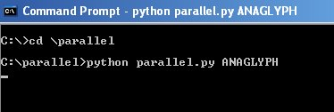

The following will be displayed:

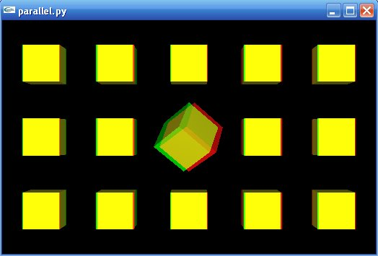

Toedin

Replace ANAGLYPH with SHUTTER or NONE to display the desired option

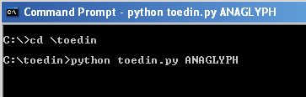

The following will be displayed:

